**QnQ HEALTHCARE**

**(PLACING AN ORDER)**

**INTRODUCTION:**

* Call the healthcare center for appointment scheduling, prescription refills, order inquiries, and billing concerns.
* In emergencies, contact the center for immediate assistance.
* Receive follow-up calls after medical procedures to ensure patient well-being.
* Contact calls or medical-related chats to verify the placement of orders through phone or WhatsApp.

**AGENDA:**

1. How to Install the app
2. How to Sign in
3. How to upload Prescription
4. How to place the order
5. Miscellaneous

**1. How to Install the app:**

1. Open the Google Play Store.
2. Search for "QnQ Healthcare" in the Google Play Store.
3. Install the app on your device.

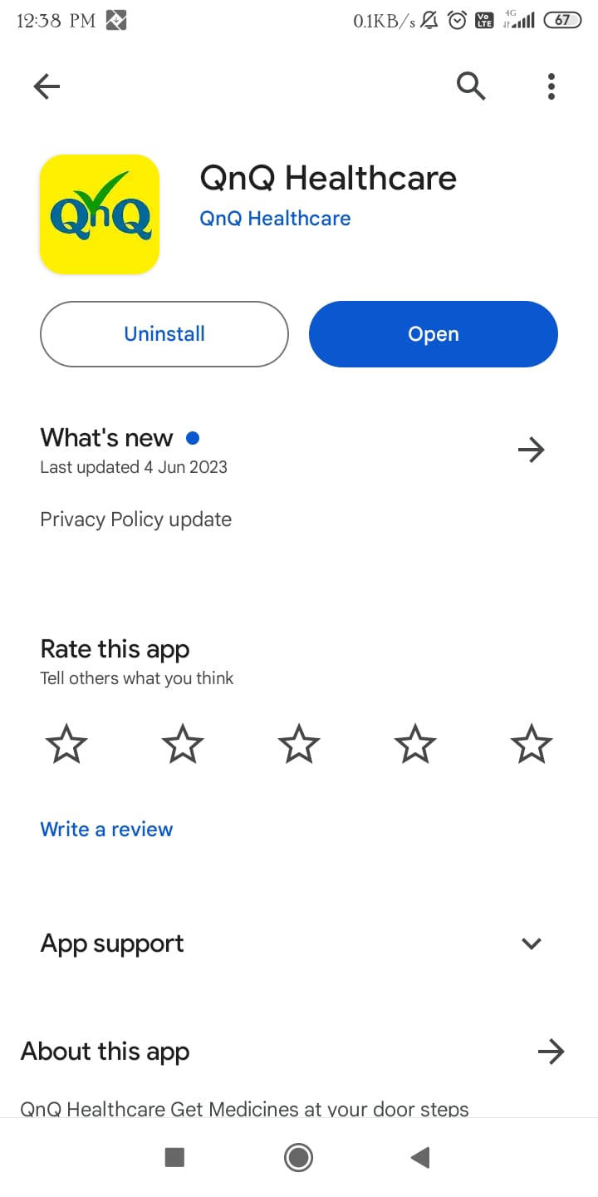

1. access the app on your mobile or other devices after installation.

**2. HOW TO SIGN-IN**

1. Open the 'QNQ Healthcare' app.

2. Navigate to the menu bar.

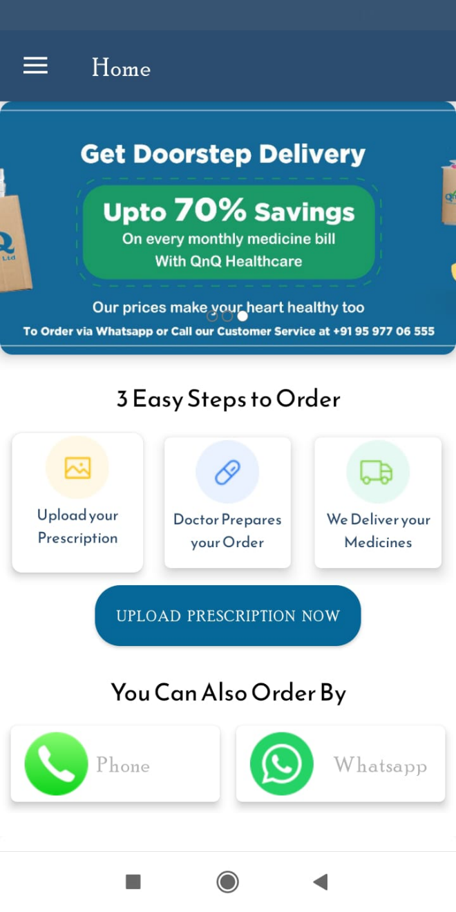

3. Locate the 'Sign-In' button.

4. Click the 'Sign-In' button to access the sign-in panel.

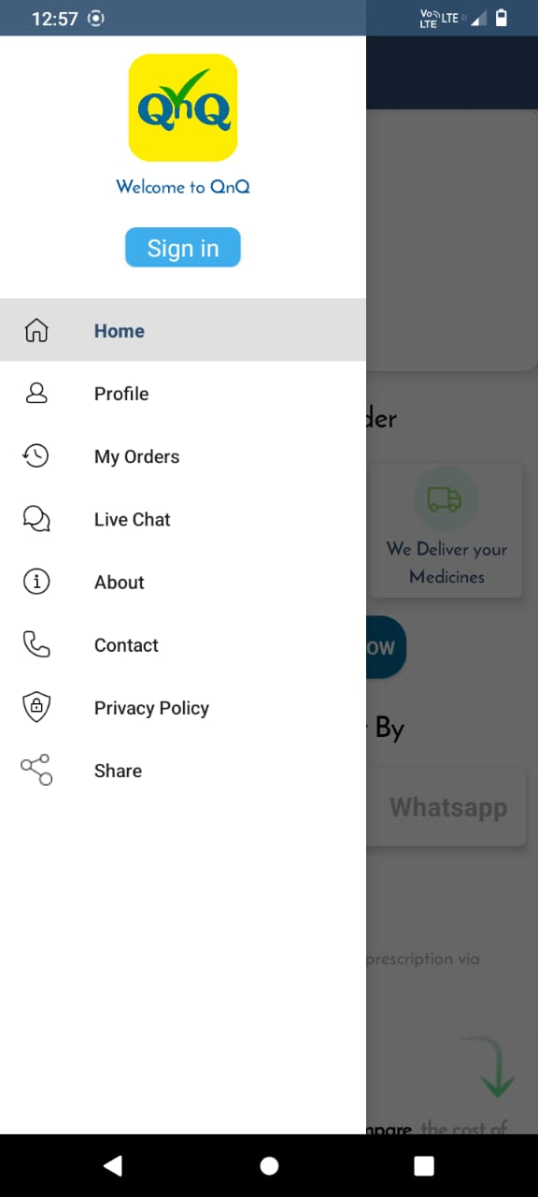

5. Enter your mobile number in the provided field.

6. Send/get the OTP (One-Time Password).

7. After receiving the OTP, enter it in the designated space.

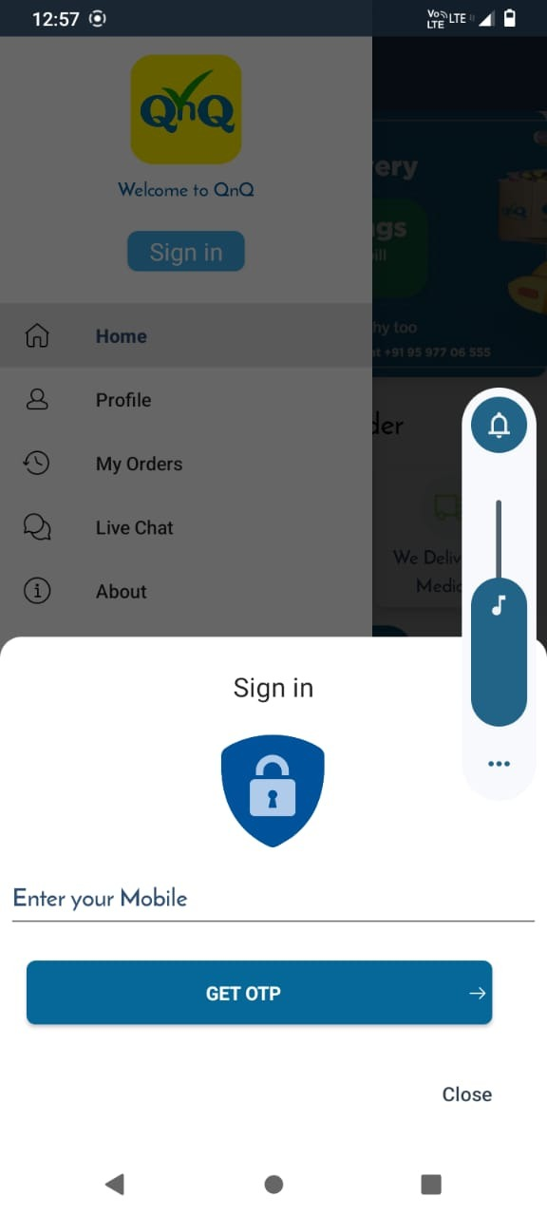

**6 & 7**

**5**

8. Complete the sign-in process by successfully entering the verification code.

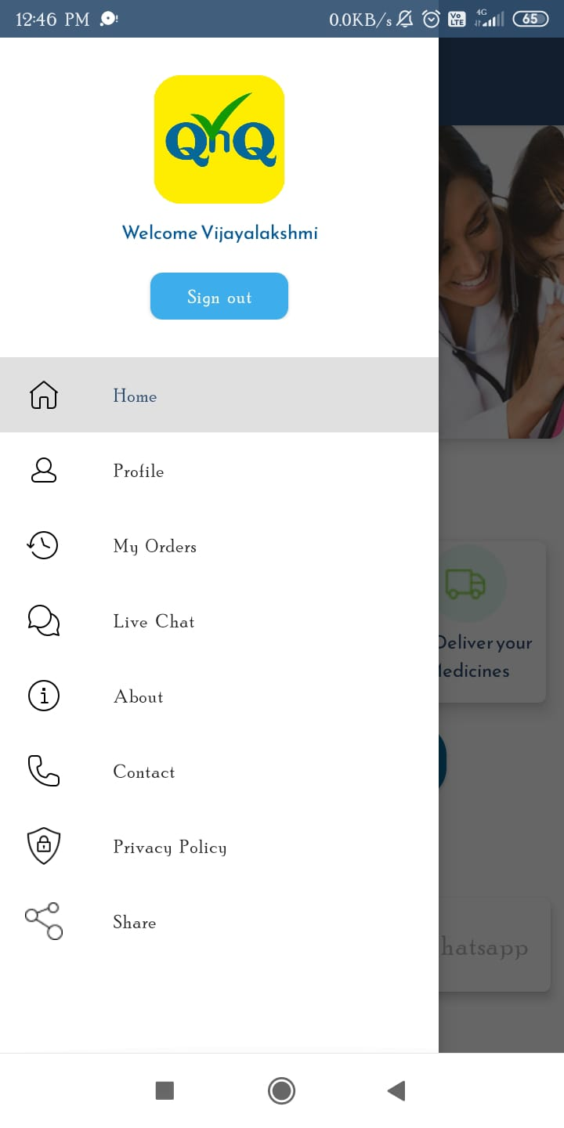

**3. How to Upload Prescription**

1. Navigate to the 'Home' section.
2. 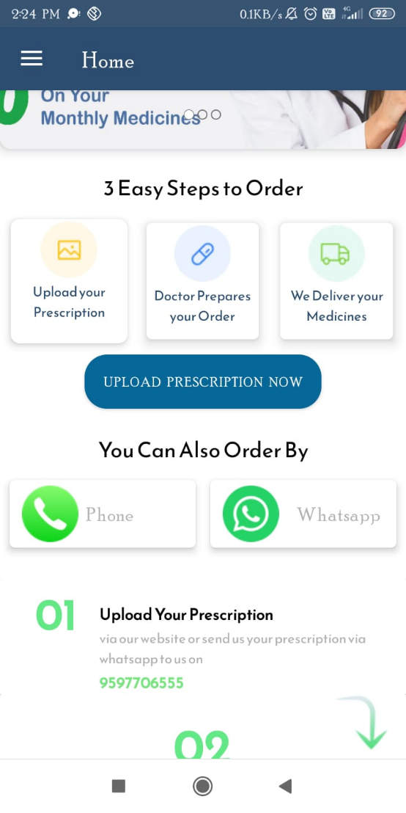Click on the 'Upload Prescription Now' button.
3. Follow the guided process to reach the 'Prescription Upload' page.
4. Find instructions for valid prescription uploads on this page.
5. Locate and select the 'Select Image' button above the instructions.

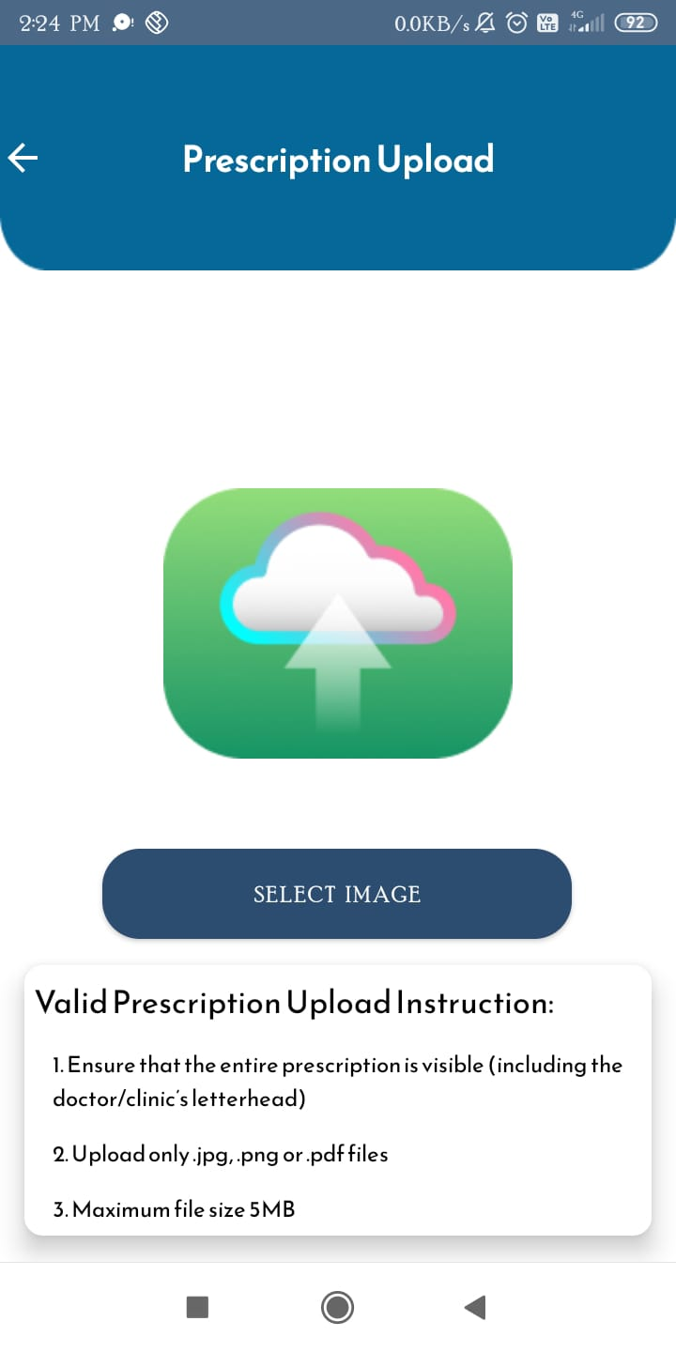

**4,6 & 7**

**3**

**5**

1. Upload the relevant prescription by following the provided guidelines.
2. Upon successful completion of the upload, the prescription is sent to the 'Call Center.'
3. Expect a follow-up from the proficient Call Center staff, who will reach out to you.

**4. How to place the order**

1. Explore three convenient ordering options.

2. Navigate to the 'Home' section.

3. Identify two primary methods for placing orders.

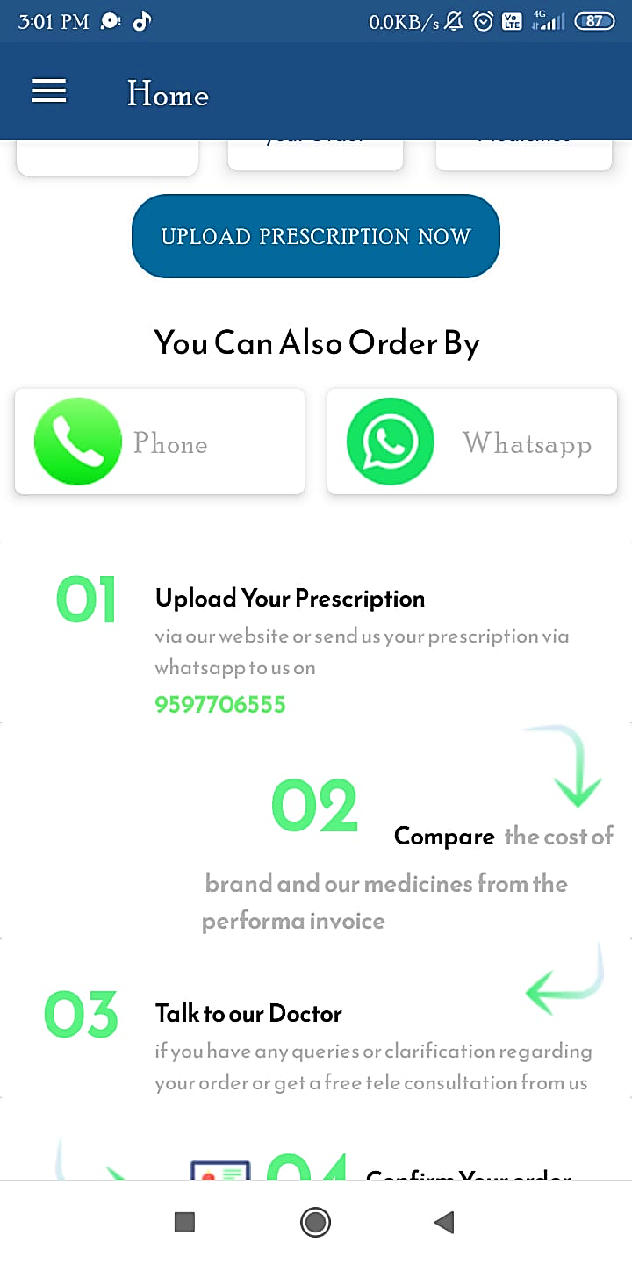

4. Choose the first method by calling the 'Call Center' to submit your order.

5. Alternatively, Choose the second method by clicking on the WhatsApp option.

6. Follow the link directly to the 'Call Center' WhatsApp chat page.

7. Within the chat and Call, proceed to place your order.

8. The instructions to place the order are displayed below the 'icons.'

9. It displays medicine comparison, doctor prescriptions, and medicine delivery status; these processes are managed in the "Call Centre."

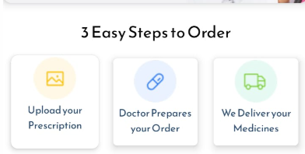

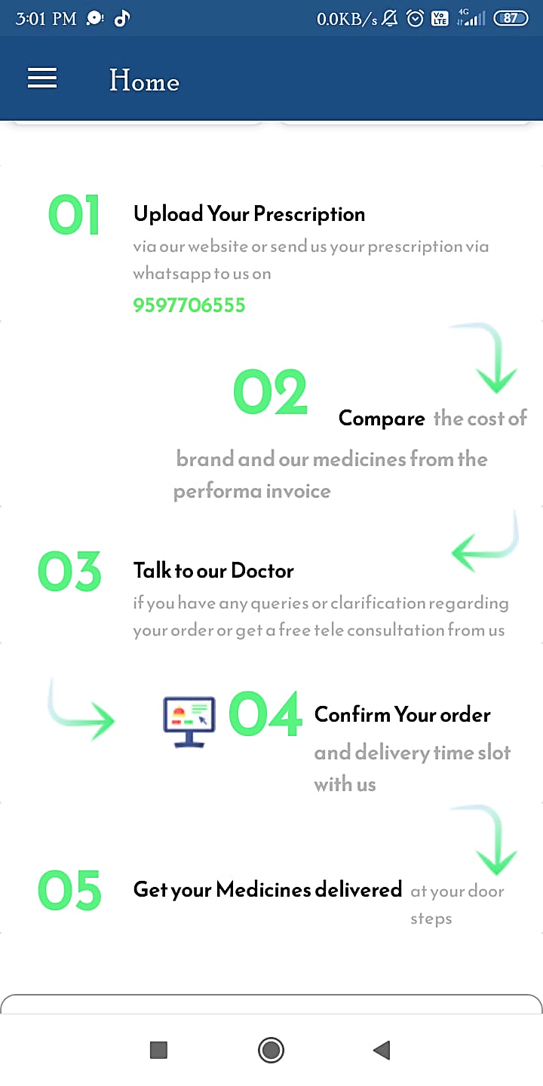

**8 & 9**

**5. Miscellaneous**

1. Navigate the menu bar; it shows options like "Home," "Profile," "My Orders," "About," "Contact," etc.



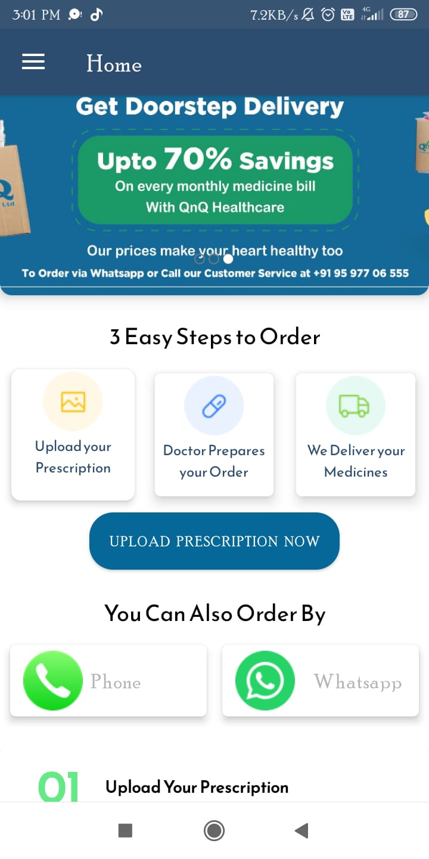**Home:**

**Profile:**

1. The profile shows your sign-in details.

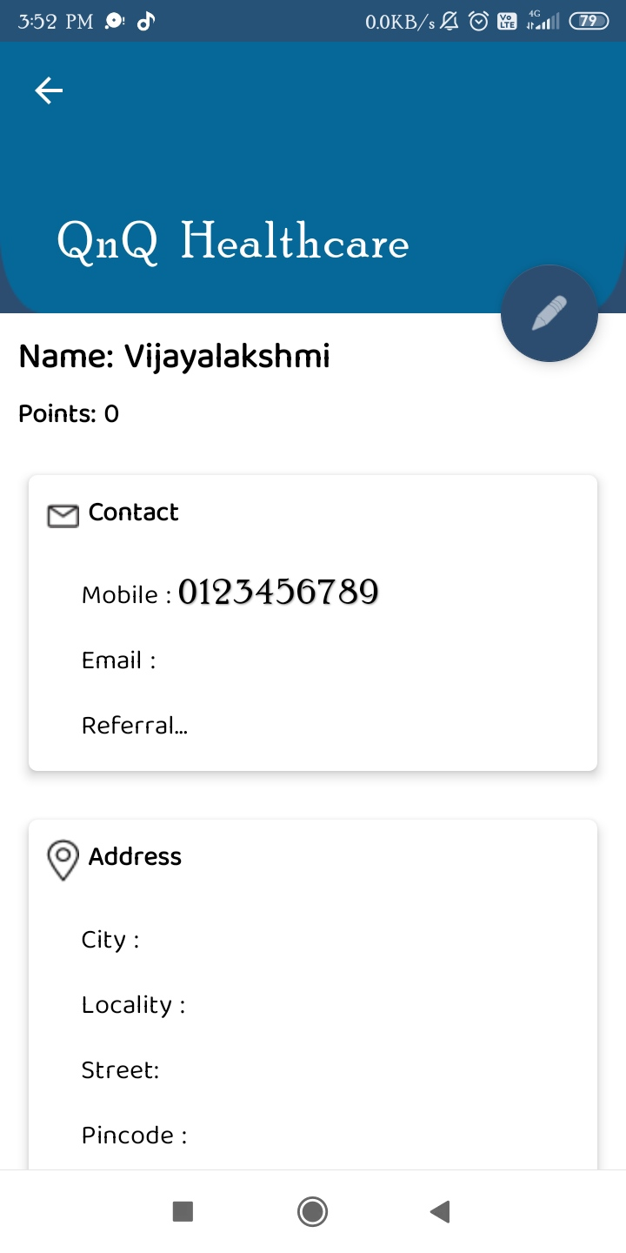

**My Orders:**

1. "My order" is displayed if customers have any orders. The "Call Centre" handles the display of orders, showing details from the previous day and the current day, including delivery status and invoices.

**Live chat:**

1. "Live chat" is displayed if you want to place an order through live chat.

**About:**

1. 'About' displays information about "QnQ HEALTHCARE," including our "VISION AND MISSION."

**Contact:**

1. 'CONTACT' displays our contact number and address.

